Laboratoriya ishi №8

Fan: Web ilovalar

Mavzu: CSS Flexbox va Grid yordamida sahifa tartibini yaratish

1. Maqsad:
Veb sahifada Flexbox va Grid texnologiyalaridan foydalanib, bloklarning joylashuvini tartibga solish va moslashuvchan (responsive) dizayn yaratishni o‘rganish.

2. Nazariy ma’lumot

Flexbox (Flexible Box Layout)
Flexbox — bu bir o‘lchamli (bir yo‘nalishda) joylashuv tizimi bo‘lib, elementlarni gorizontal yoki vertikal yo‘nalishda oson joylashtirishga yordam beradi.
Asosiy xossalar:
display: flex; — konteynerni Flexboxga aylantiradi
justify-content — elementlarni gorizontal joylashtiradi
align-items — vertikal yo‘nalishda joylashtiradi
flex-wrap — elementlarni keyingi qatorga o‘tkazadi

Grid Layout
Grid — bu ikki o‘lchamli (qator va ustun) tartib tizimi bo‘lib, sahifani tarmoq shaklida joylashtirish imkonini beradi.

Asosiy xossalar:
display: grid; — konteynerni Grid tizimiga aylantiradi
grid-template-columns — ustunlar sonini belgilaydi
grid-template-rows — qatorlar balandligini belgilaydi
gap — qator va ustunlar orasidagi bo‘shliq

3. Amaliy qism

Fayl tuzilmasi:
/lab8/
│
├── index.html
└── style.css

index.html
<!DOCTYPE html><html lang="uz"><head>
<meta charset="UTF-8">
<meta name="viewport" content="width=device-width, initial-scale=1.0">
<title>CSS Flexbox va Grid bilan sahifa tartibi</title>
<link rel="stylesheet" href="style.css"></head><body>
<header>
<h1>CSS Flexbox va Grid yordamida sahifa tartibi</h1>
</header>

<nav class="navbar">
<a href="#">Bosh sahifa</a>
<a href="#">Biz haqimizda</a>
<a href="#">Xizmatlar</a>
<a href="#">Bog‘lanish</a>
</nav>

<main class="content">
<section class="flex-container">
<h2>Flexbox misoli</h2>
<div class="flex-items">
<div class="item">1</div>
<div class="item">2</div>
<div class="item">3</div>
<div class="item">4</div>
</div>
</section>

<section class="grid-container">
<h2>Grid Layout misoli</h2>
<div class="grid-items">
<div class="grid-item">A</div>
<div class="grid-item">B</div>
<div class="grid-item">C</div>
<div class="grid-item">D</div>
<div class="grid-item">E</div>
<div class="grid-item">F</div>
</div>
</section>
</main>

<footer>
<p>&copy; 2025. Web ilovalar fanidan laboratoriya ishi.</p>
</footer></body></html>

style.css
/* Umumiy sahifa dizayni */body {
font-family: 'Segoe UI', sans-serif;
margin: 0;
padding: 0;
background-color: #f5f7fa;
color: #333;
}
header {
background-color: #0078d4;
color: white;
text-align: center;
padding: 20px;
text-transform: uppercase;
}
/* Navigatsiya (Flexbox) */.navbar {
display: flex;
justify-content: center;
background-color: #005fa3;
padding: 10px 0;
}
.navbar a {
color: white;
text-decoration: none;
margin: 0 15px;
font-weight: bold;
transition: color 0.3s ease;
}
.navbar a:hover {
color: #ffd700;
}
/* Asosiy kontent */.content {
padding: 20px;
}
/* FLEXBOX QISMI */.flex-container {
margin-bottom: 40px;
text-align: center;
}
.flex-items {
display: flex;
justify-content: space-around;
flex-wrap: wrap;
background-color: #e8f0fe;
padding: 20px;
border-radius: 8px;
}
.item {
background-color: #0078d4;
color: white;
font-size: 20px;
padding: 20px;
width: 100px;
text-align: center;
margin: 10px;
border-radius: 6px;
transition: transform 0.3s ease;
}
.item:hover {
transform: scale(1.1);
}
/* GRID QISMI */.grid-container {
text-align: center;
}
.grid-items {
display: grid;
grid-template-columns: repeat(auto-fit, minmax(150px, 1fr));
gap: 15px;
background-color: #e3f2fd;
padding: 20px;
border-radius: 8px;
}
.grid-item {
background-color: #00bfa5;
color: white;
font-size: 20px;
padding: 20px;
border-radius: 6px;
transition: transform 0.3s ease;
}
.grid-item:hover {
transform: scale(1.05);
}
/* Footer */footer {
background-color: #0078d4;
color: white;
text-align: center;
padding: 15px;
font-size: 14px;
}

4. Natija
Brauzerda sahifa ochilganda:
*Navigatsiya paneli Flexbox yordamida markazga joylashtirilgan.
*Flexbox bo‘limida elementlar gorizontal holda joylashadi va ekran torayganda pastga tushadi.
*Grid bo‘limida elementlar panjara ko‘rinishida joylashadi, har bir element avtomatik moslashadi.
*Hover effekti bilan elementlar kattalashadi.
Topshiriq: Sumka do’konining sayti

<!DOCTYPE html>
<html lang="uz">
<head>
<meta charset="UTF-8">
<title>Brend Sumkalar Do'koni</title>
<style>
body {
font-family: Arial, sans-serif;
background-color: #ffc0cb; /* Pushti fon */
margin: 20px;
}
h1 {
text-align: center;
color: #fff;
text-shadow: 1px 1px 2px #000;
}
.container {
display: flex;
flex-wrap: wrap;
justify-content: center;
gap: 20px;
}
.product {
background-color: #fff;
border: 1px solid #ddd;
border-radius: 8px;
width: 250px;
padding: 10px;
box-shadow: 0 2px 5px rgba(0,0,0,0.1);
}
.product img {
width: 100%;
height: auto;
border-radius: 5px;
}
.product h2 {
font-size: 18px;
margin: 10px 0 5px;
text-align: center;
}
.product p {
font-size: 16px;
color: #555;
text-align: center;
}
</style>
</head>
<body>
<h1>Brend Sumkalar Do'koni</h1>
<div class="container">

<div class="product">
<img src="https://lombard-chasov.ru/images/products/WGhLHVZZblM0aJVNIeBFB6Wf2x3Ol0awkmsytSf4.jpg" alt="Chanel sumkasi">
<h2>Chanel</h2>
<p>Narxi: 250 000 so'm</p>
<p> Qizil, Oq, Qora ranglari bor</p>
</div>
<div class="product">
<img src="https://images.satu.kz/182561790_w640_h640_sumka-gucci-gg.jpg" alt="Gucci sumkasi">
<h2>Gucci</h2>
<p>Narxi: 300 000 so'm</p>
<p> To'q qizil, Oq, Qora ranglari bor</p>
</div>
<div class="product">
<img src="https://images.prom.ua/6582789822_w640_h640_sumka-louis-vuitton.jpg" alt="Louis Vuitton sumkasi">
<h2>Louis Vuitton</h2>
<p>Narxi: 200 000 so'm</p>
<p> Oq, Kulranglari bor</p>
</div>
<div class="product">
<img src="https://cdn1.ozone.ru/s3/multimedia-1-5/c600/7056374333.jpg" alt="Dior sumkasi">
<h2>Dior</h2>
<p>Narxi: 280 000 so'm</p>
<p> Oq va Pushti gulli ranglari bor</p>
</div>
<div class="product">
<img src="https://images.prom.ua/6522454428_w640_h640_zhenskaya-sumka-stil.jpg" alt="Zara sumkasi">
<h2>Zara</h2>
<p>Narxi: 450 000 so'm</p>
<p> Oq, Qora Kulranglari bor</p>
</div>
<div class="product">
<img src="https://images.uzum.uz/cmu93m125kub33f23do0/original.jpg" alt="Hermès sumkasi">
<h2>Hermès</h2>
<p>Narxi: 350 000 so'm</p>
<p> Har xil turdagi ranglari bor</p>
</div>
</div>
</body>
</html>

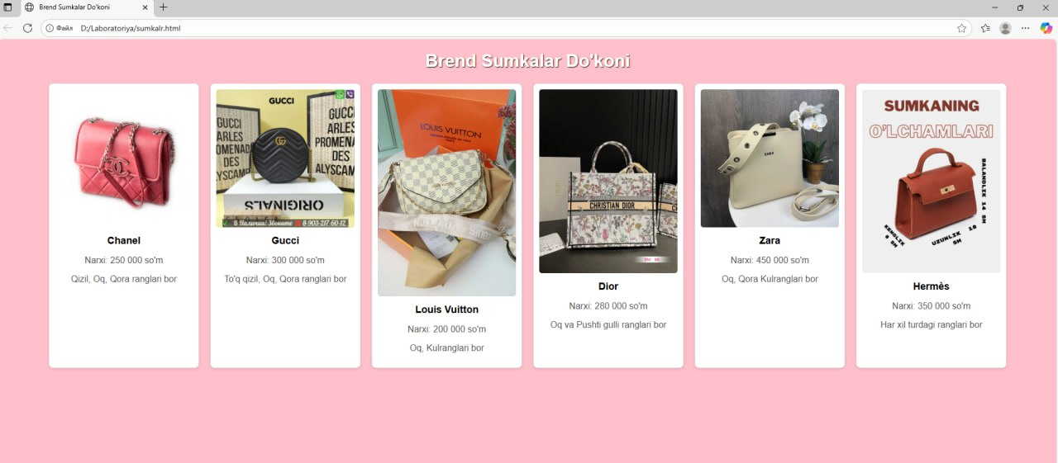

5. Xulosa
Ushbu laboratoriya ishida CSS Flexbox va CSS Grid texnologiyalaridan foydalanib, sahifadagi elementlarni tartibli va moslashuvchan joylashtirish usullari o‘rganildi.
Flexbox bir o‘lchamli (qator yoki ustun) tartib yaratishda qulay bo‘lsa, Grid ikki o‘lchamli (qator va ustun) tartibni shakllantirishda samarali hisoblanadi.

